**Schedule**

Here are the instructions if you want to keep using the schedule with the map. A copy of the pxd file for the elementary meet was given to you with the USB, and the UBC schedule pxd file is on the Admin Git page.

You will need Google Chrome to edit it.

* Open Google Chrome and go to pixlr.com/editor
* Choose “Open Image From Computer” and navigate to the pxd file.
* If “Layers” isn’t open on the far right go to View->Layers to have it displayed  
  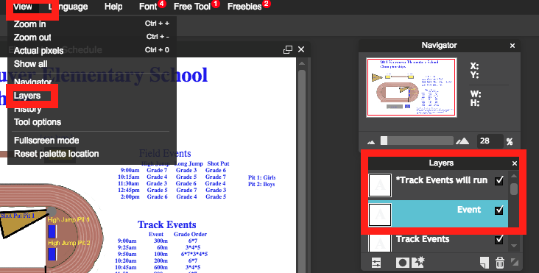
* Choose the “A” on the left hand panel to enable editing the text boxes.   
  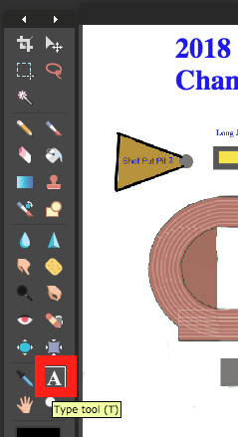
* Choose the text box you want to edit from the Layers menu, then click on some of the text. If an empty text box shows up then you have probably chosen the wrong layer. Just press the little garbage can and try a different one.   
  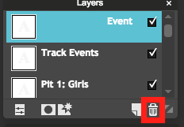
* If you want to change the picture at all you’ll have to experiment and play with the painting tools on the left hand side.
* When you are done, go to File->save… then keep the default settings and save this file with the same name to it’s original folder to over-write the old one.
* Then go back to File->save… and change the type to JPEG and increase the quality up to 100. Save this file in the folder that is synced to your github for that meet, and follow the GIT directions to push it online.

